What is corrosion?

Corrosion is a natural process that involves the deterioration of metal components. According to NACE International, corrosion is “the destruction of a substance (usually a metal) or its properties because of a reaction with its environment.” This ultimately causes potentially severe damage to your building or application and can become very costly to repair.

How corrosion occurs?

Corrosion is an electrochemical reaction that appears in several forms, such as chemical corrosion and atmospheric corrosion, the latter of which is the most common form. When acidic substances (including water) come in contact with metals, such as iron and/or steel, rust begins to form. Rust is the result of corroding steel after the iron (Fe) particles have been exposed to oxygen and moisture (e.g., humidity, vapour, immersion). When steel is exposed to water, the iron particles are lost to the water’s acidic electrolytes. The iron particles then become oxidized, which results in the formation of Fe⁺⁺. When Fe⁺⁺ is formed, two electrons are released and flow through the steel to another area of the steel known as the cathodic area.

Oxygen causes these electrons to rise up and form hydroxyl ions (OH). The hydroxyl ions react with the FE⁺⁺ to form hydrous iron oxide (FeOH), better known as rust. Where the affected iron particles were, has now become a corrosion pit, and where they are now, is called the corrosion product (rust).

Corrosion can happen at any rate, depending on the environment that the metal is in. However, since atmospheric corrosion is so widespread, it is recommended to take effective precautionary measures when it comes to corrosion prevention

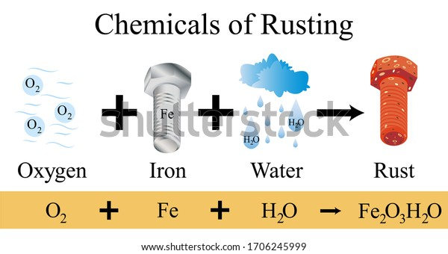

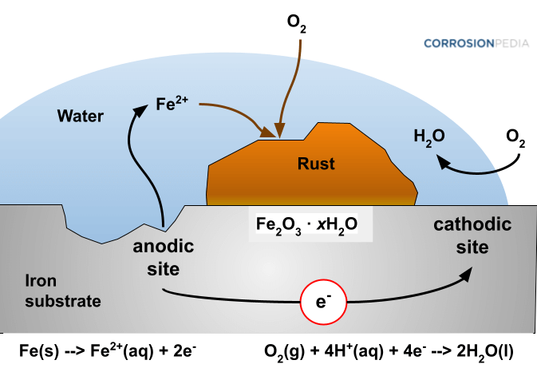

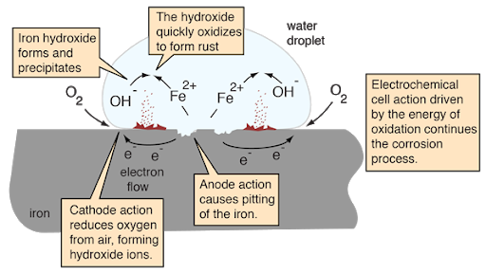

Removing and treating rust

Depending on the situation and application, you may be able to treat the area that has corroded. If the affected area is small and treatable, you may require some tools and products to remove it. Begin by removing the rust from the metal using a tool such as a grinding wheel or needle gun.  Be careful not to cause any additional damage to the metal.

For large corroded areas, you may want to consider a permanent protective coating, such as CSL’s SI-COAT Anti-corrosion Protective Coating. You will also want to take this time to look at the application as a whole for other premature signs of corrosion

**How Can I Prevent Corrosion?**

One of the best ways to prevent corrosion is to apply an [**Anti-Corrosion Protective Coating**](https://www.cslsilicones.com/en/protective-coatings/anti-corrosion.html). A protective coating protects its substrate by preventing contact between the substrate and harsh environments (atmospheric, chemical, etc.). CSL Silicones Inc, offers two kinds of anti-corrosion protective coatings (one is an environmentally responsible Low VOC option!) that are easily applied using only one coat. The [**Si-COAT® 579**](https://www.cslsilicones.com/en/protective-coatings/anti-corrosion/item/anti-corrosion-protective-coating.html?category_id=37) AC protective coating is cost-effective and offers long-lasting protection to virtually any substrate.

The coatings are environmentally responsible, have superior temperature resistance (can withstand temperatures between -76°F and 392°F), will not chalk or fade, have a low film build, require only a single-coat of application, and have outstanding UV resistance. The 180% elasticity makes the coating highly flexible, which allows for thermal expansion and contraction of the substrate to which it is applied.

**[Si-COAT Anti-Corrosion Protective Coatings](https://www.cslsilicones.com/en/protective-coatings/anti-corrosion.html)** can be applied to a wide range of applications, such as structural steel, bridges, machinery and equipment, areas with heavy corrosion, tank exteriors, metal roofs, cladding, and more.

Si-COAT AC protective coatings are ideally applied to where the necessary coverage is essential and maximum protection, adhesion, elasticity, and longevity are required